Jessica & Gage were married at the beautiful Sawtooth Acres in Pamplico, South Carolina; a family-owned homestead and wedding venue that feels just as special as the people who run it. From the charming bridal cabin where the girls spent the morning getting ready, to the stunning ceremony and reception space, and the peaceful pond that gave us the most breathtaking sunset portraits, every corner of the property felt like it was made for their day.
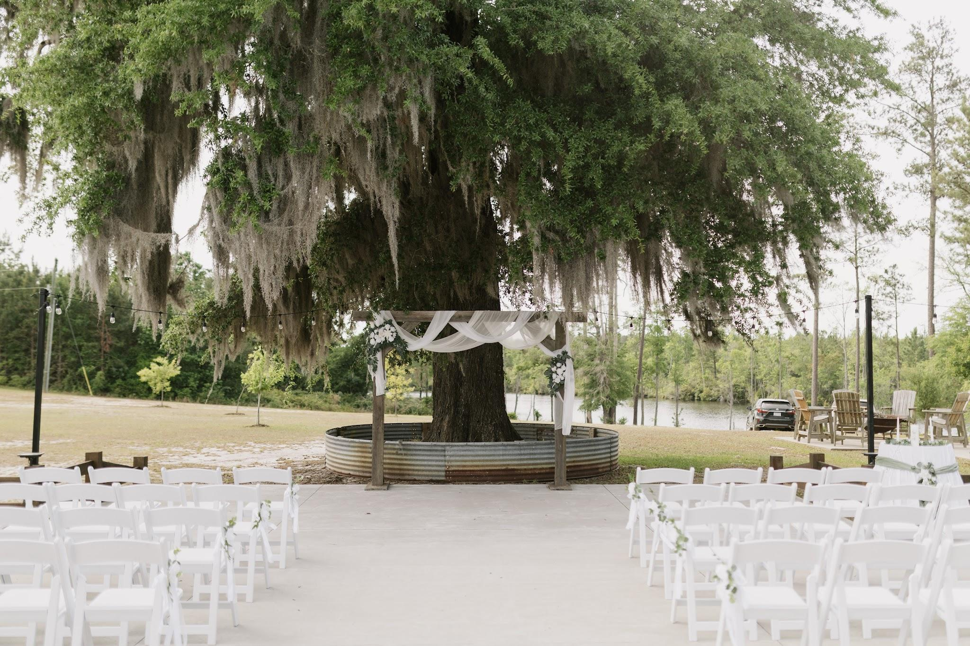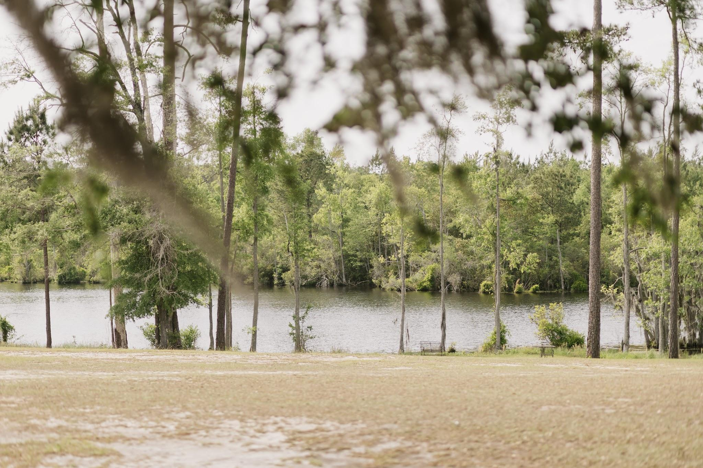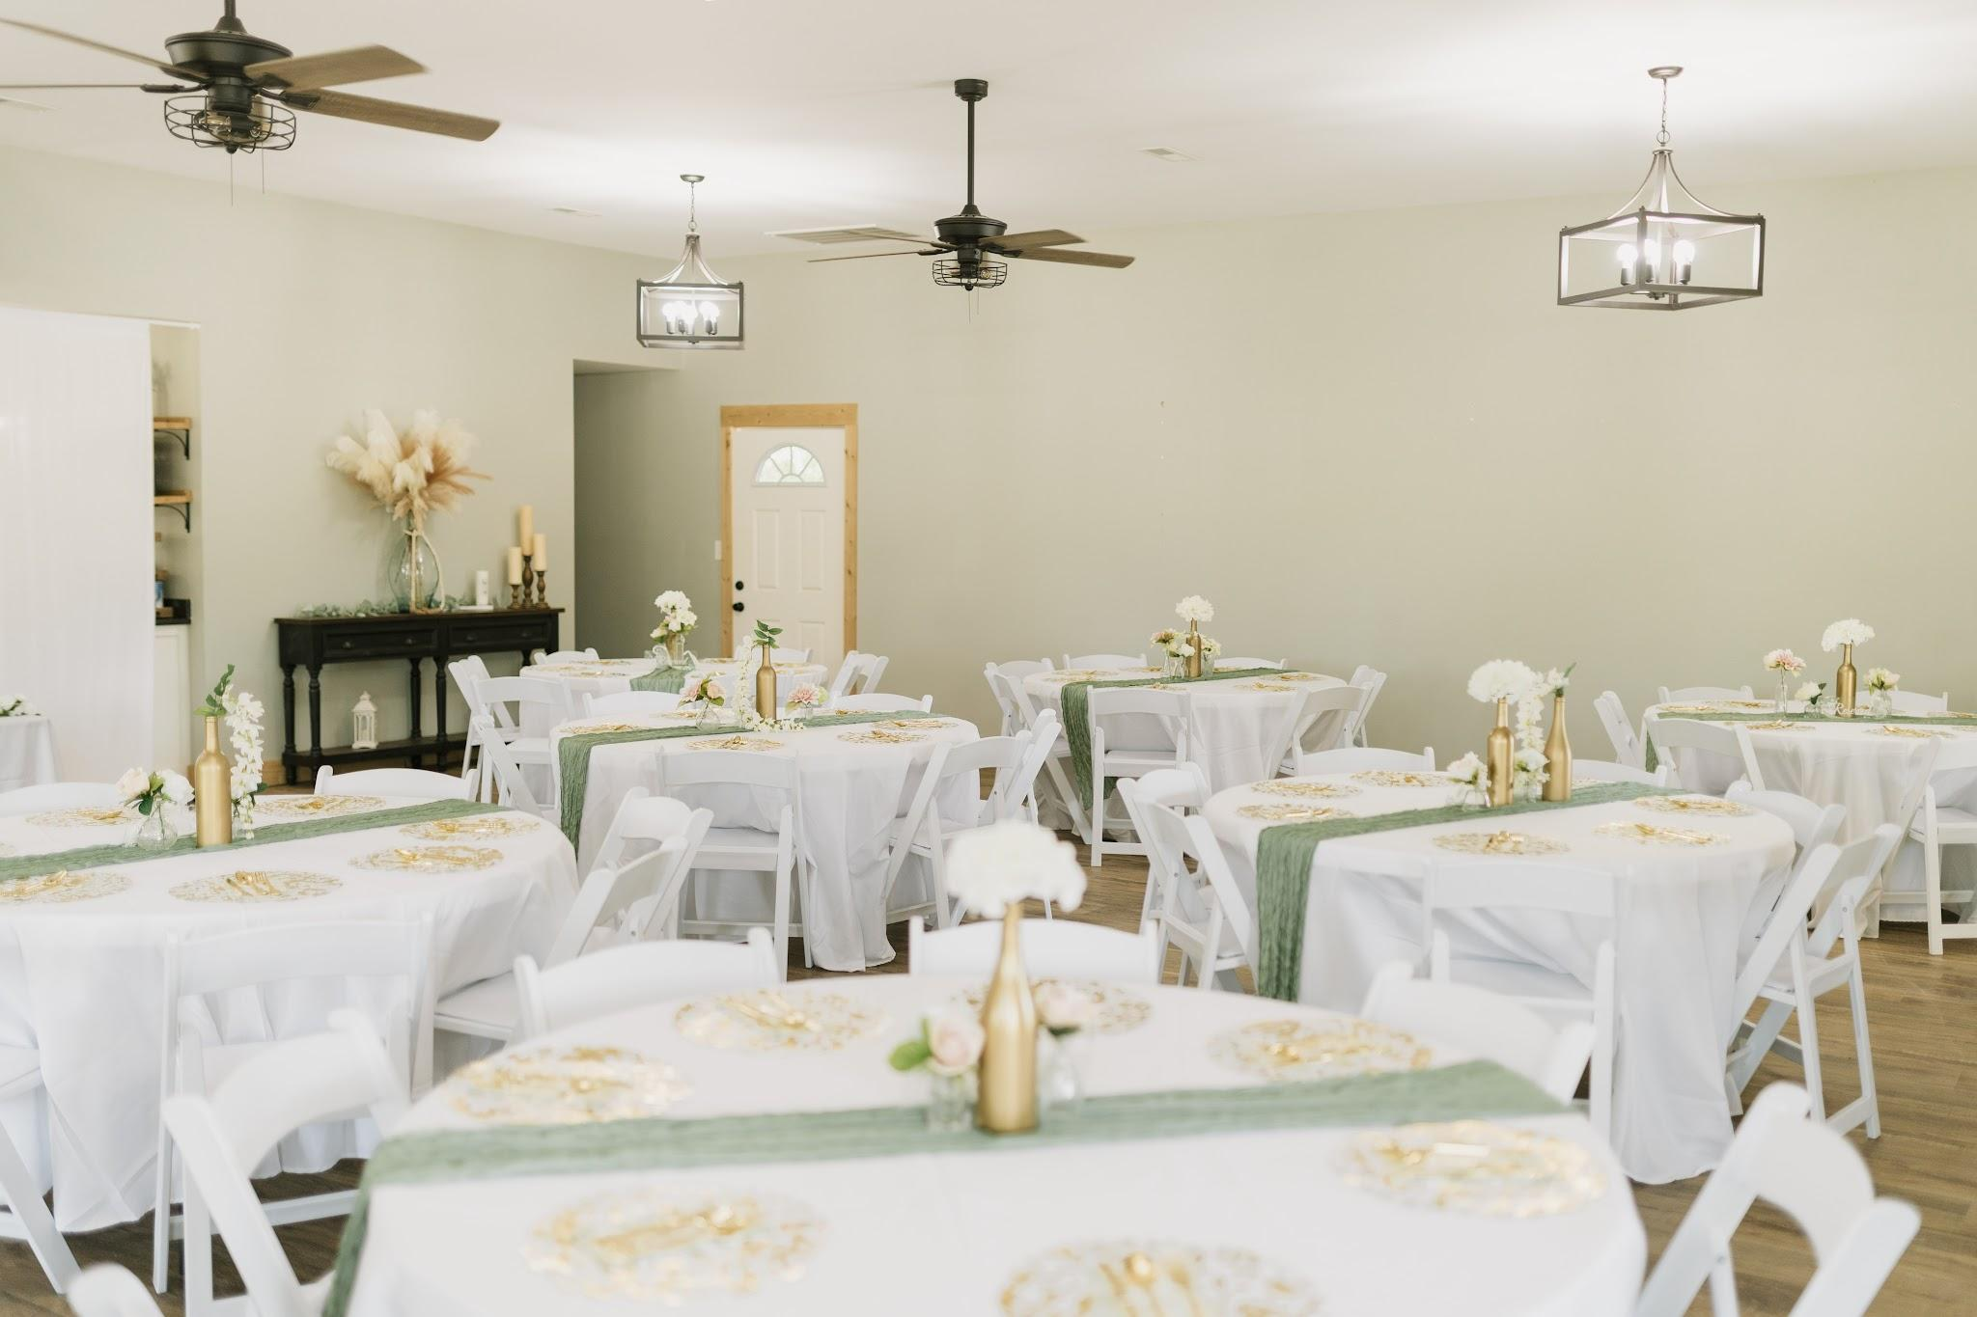
From the moment I arrived, Jessica carried herself with the most gentle, elegant presence. She brought such a calm energy to every part of the day, making everything feel effortless. She trusted me completely. From choosing photo locations to embracing creative ideas—that kind of trust is something I’ll never take for granted. It allowed us to create images that felt so authentically them.

The women standing beside her reflected that same love and support. They were there for every little moment, fluffing her dress, helping bustle it before the reception, fixing the final makeup touch-ups, and celebrating her every step of the way. Then, when the music started, they completely transformed the dance floor and made sure the celebration never slowed down.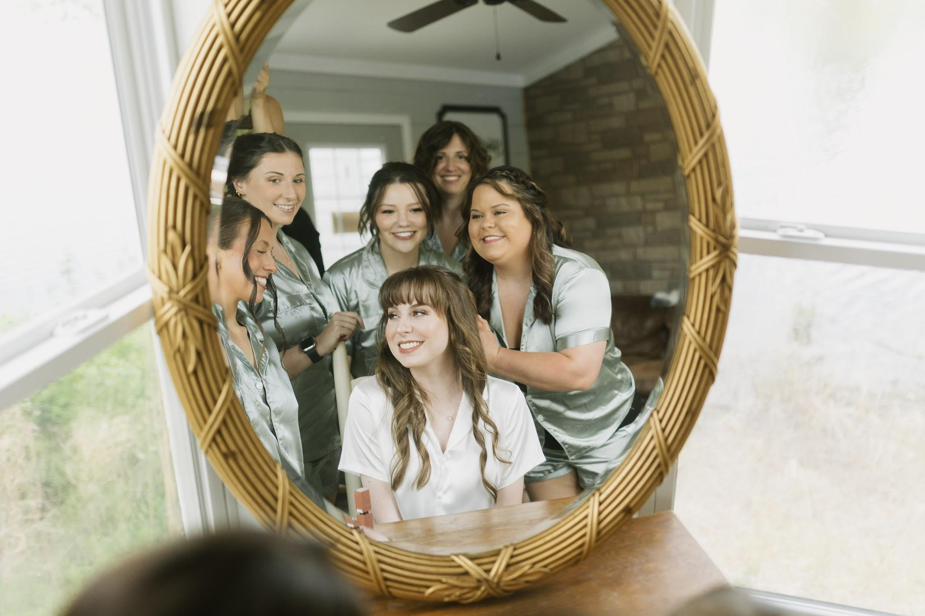
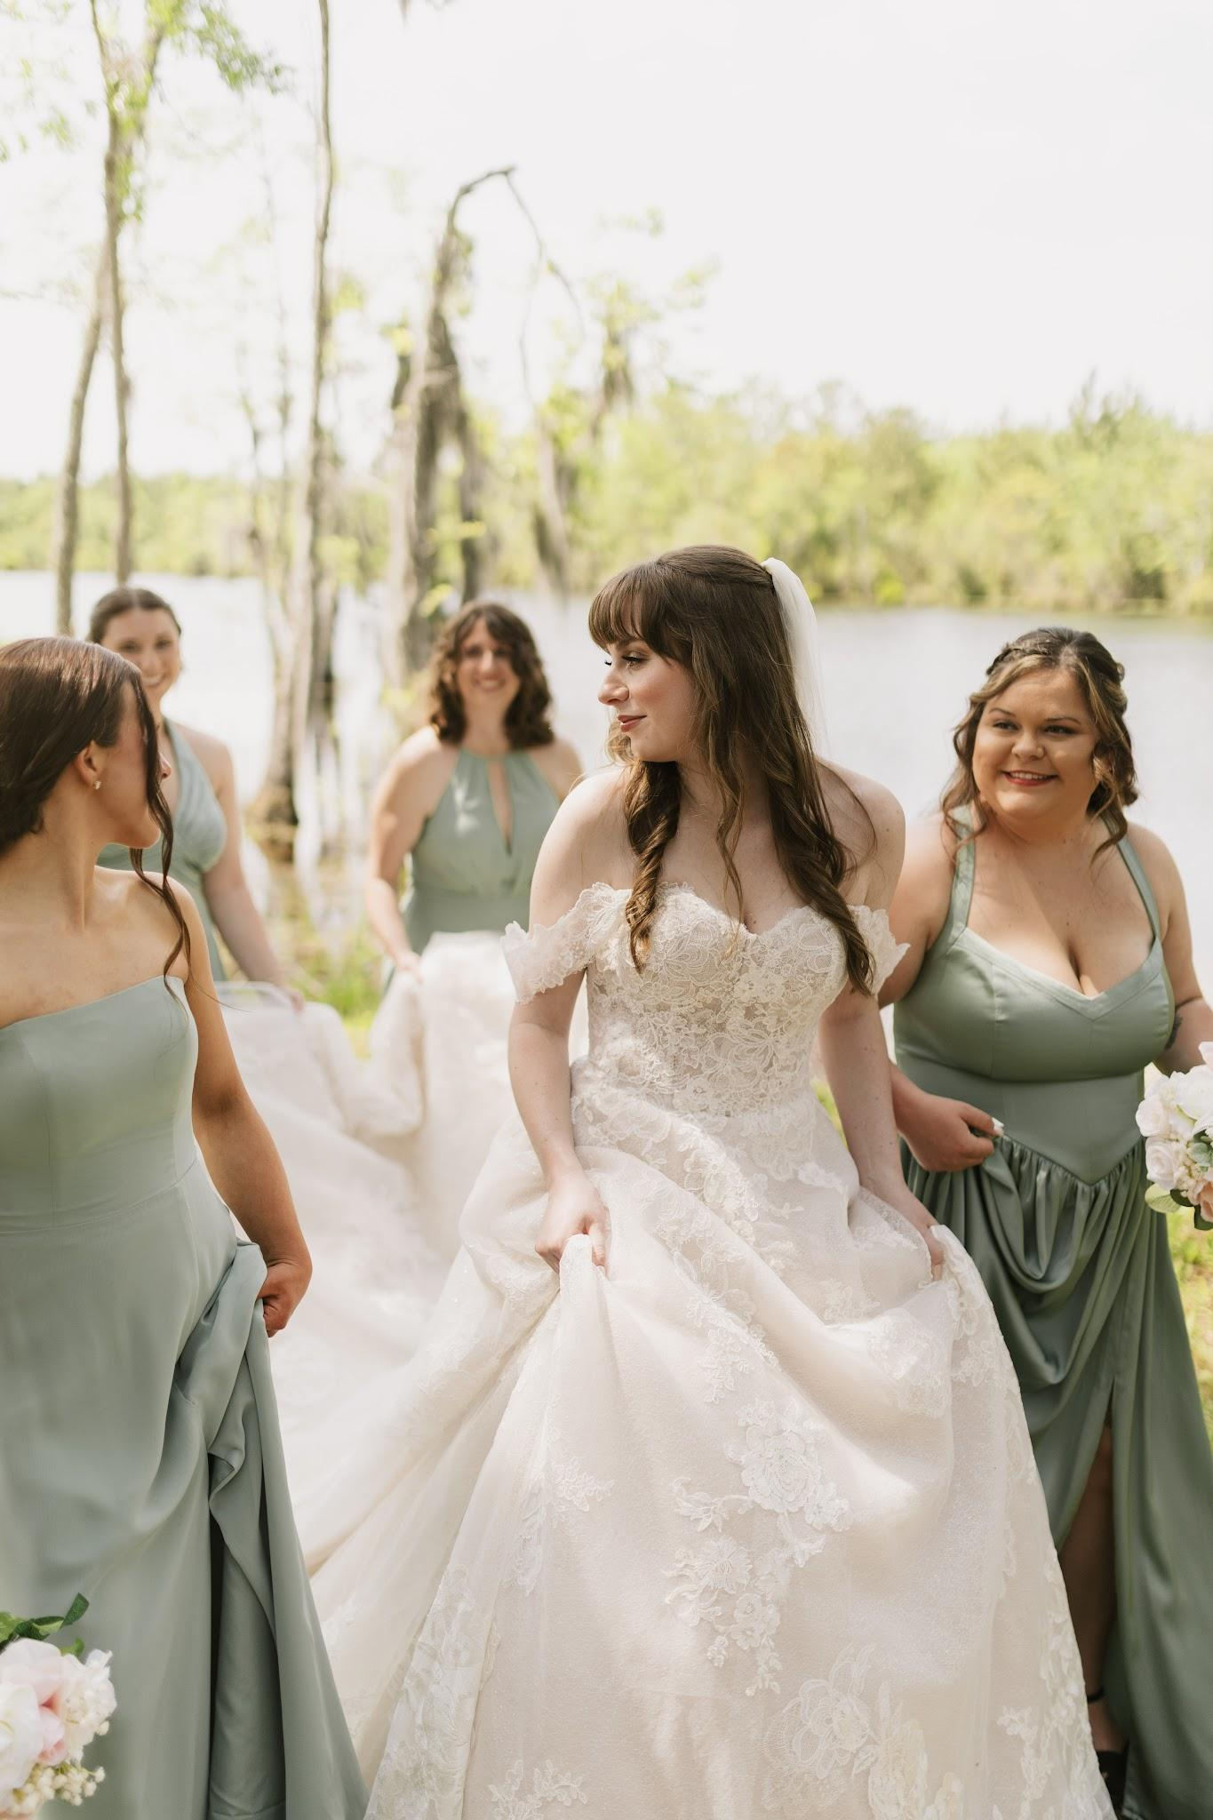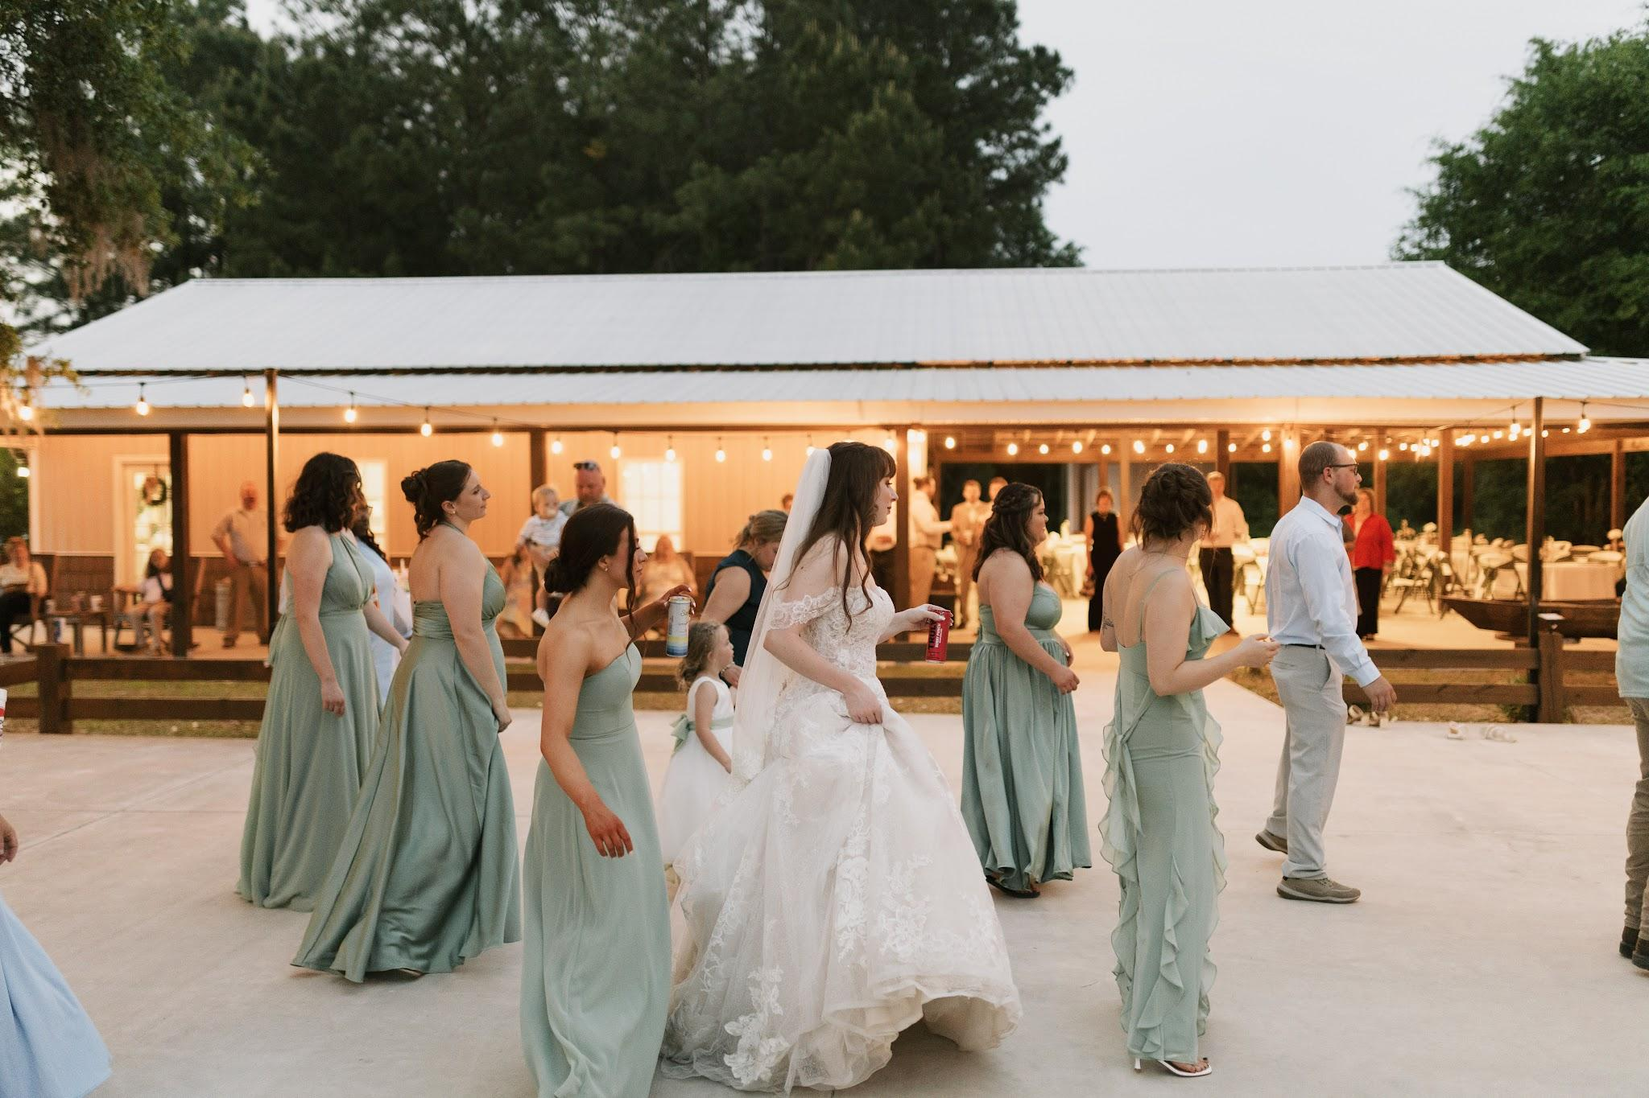
Gage’s groomsmen brought that same joy and encouragement. They were easygoing, supportive, and always ready to laugh. Photos never felt forced because they genuinely enjoyed being there together, and their excitement for Gage was evident from beginning to end.
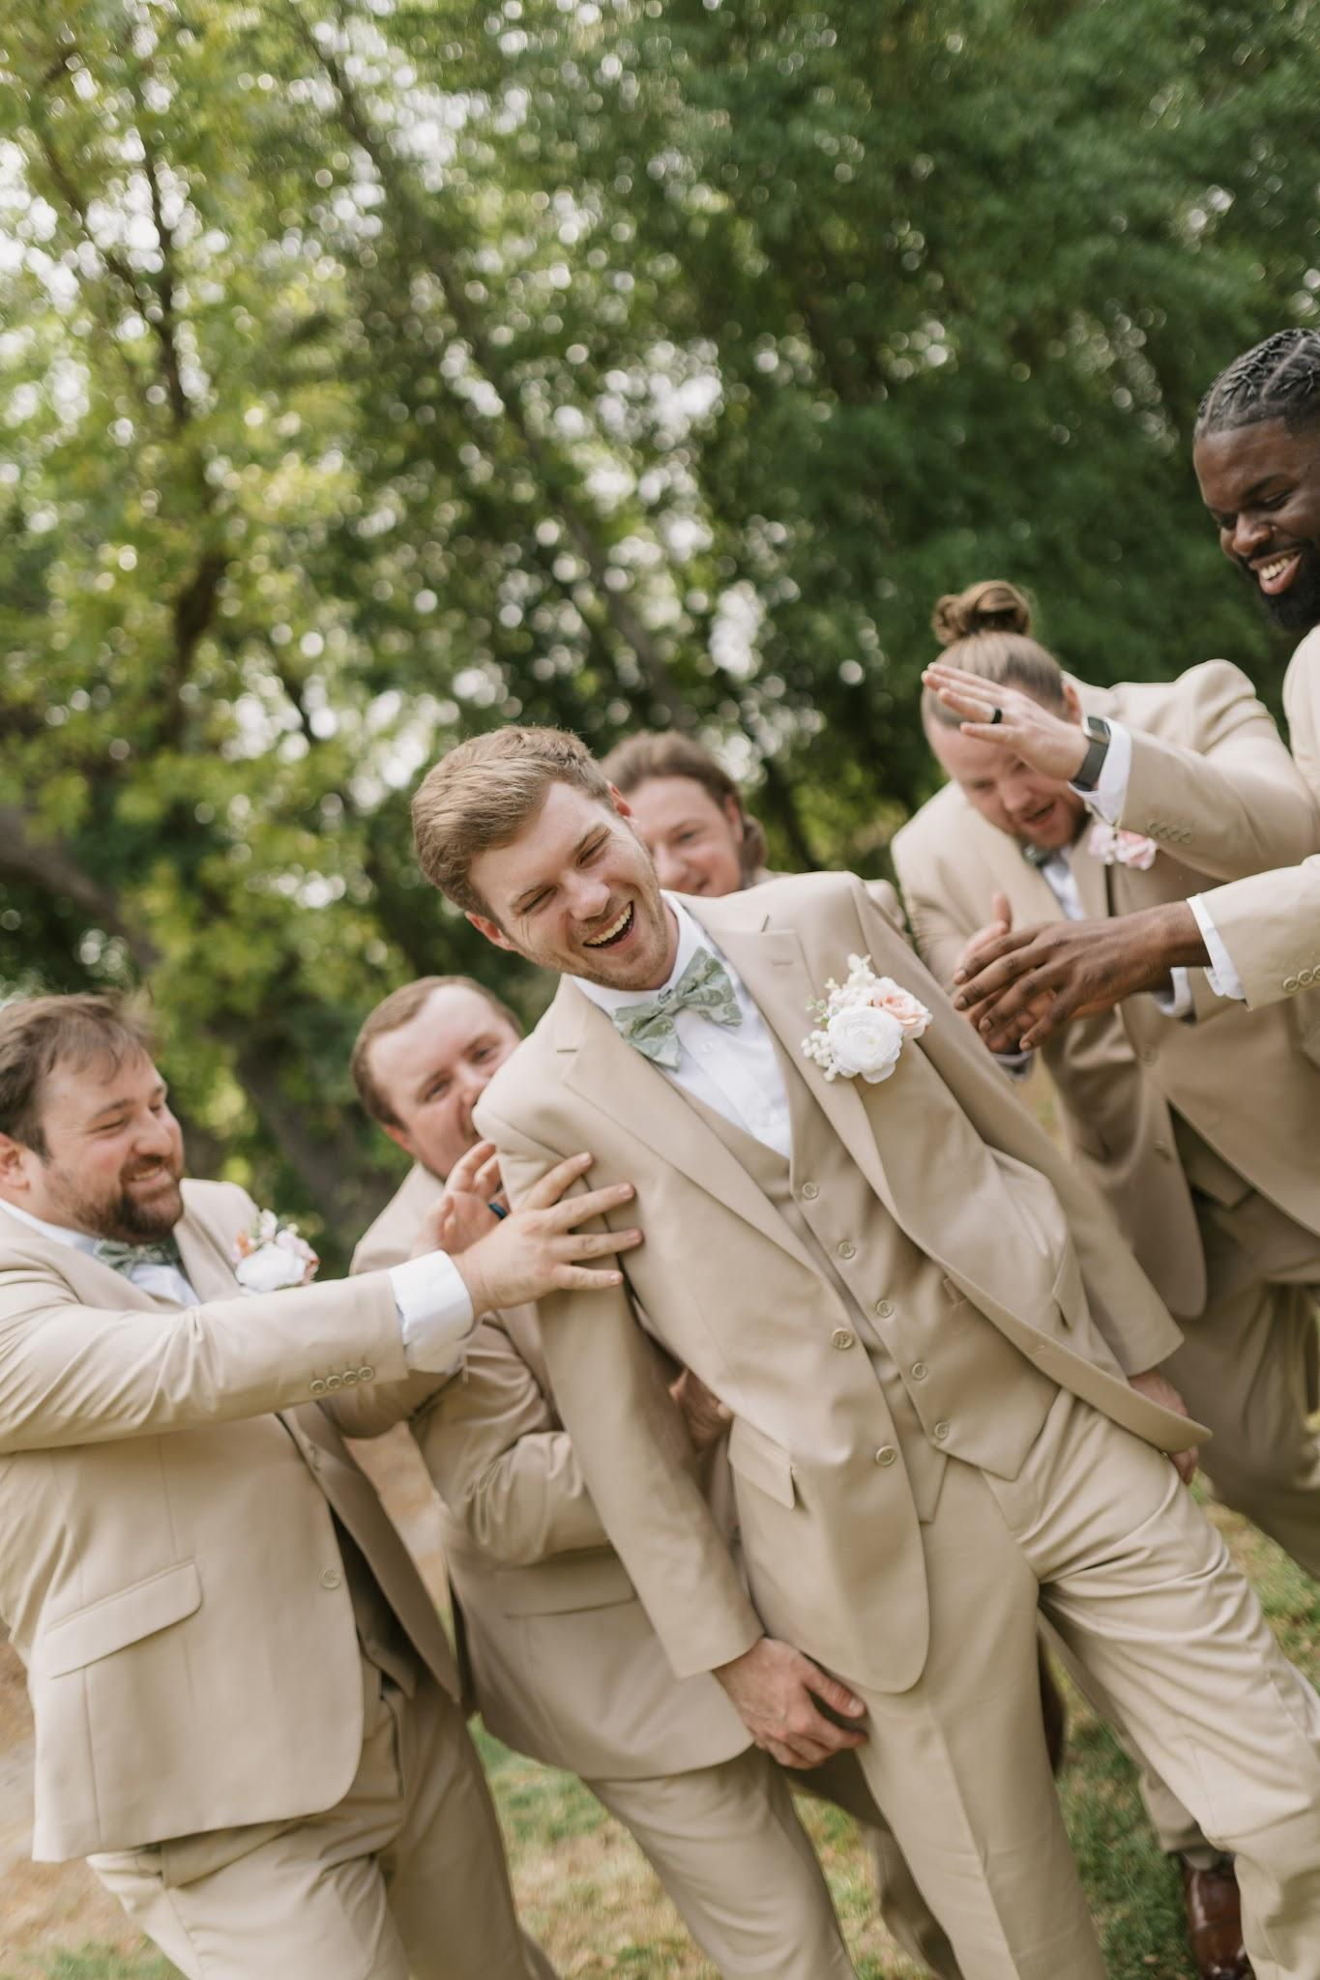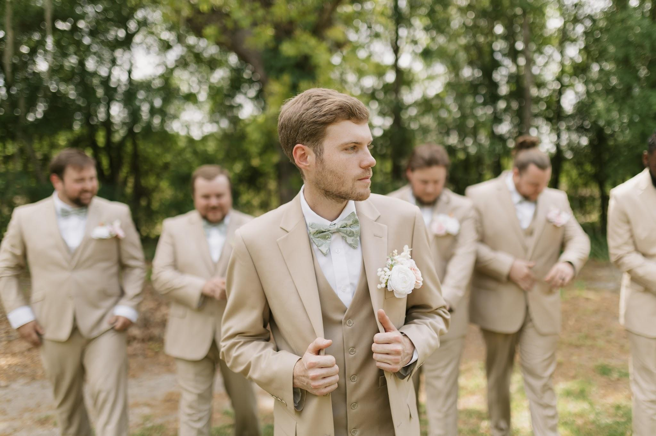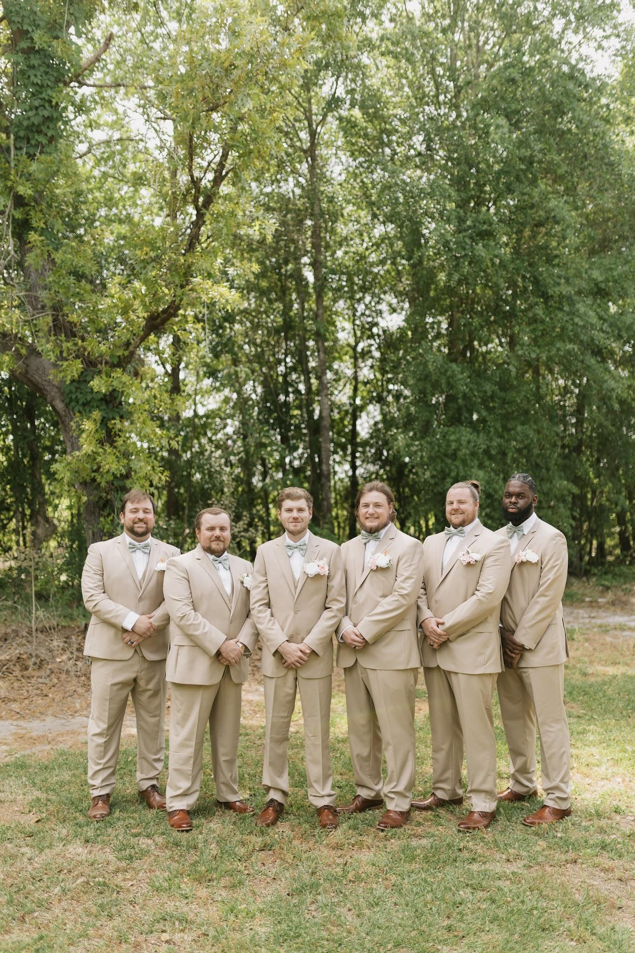
One of the most meaningful parts of the day was their ceremony, officiated by Gage’s uncle. Instead of simply marrying them, he shared words of watching their relationship grow from the very beginning. His words made the ceremony feel deeply personal and reminded everyone present that this wasn’t just the start of a marriage but the continuation of a love story so many people had been privileged to witness.
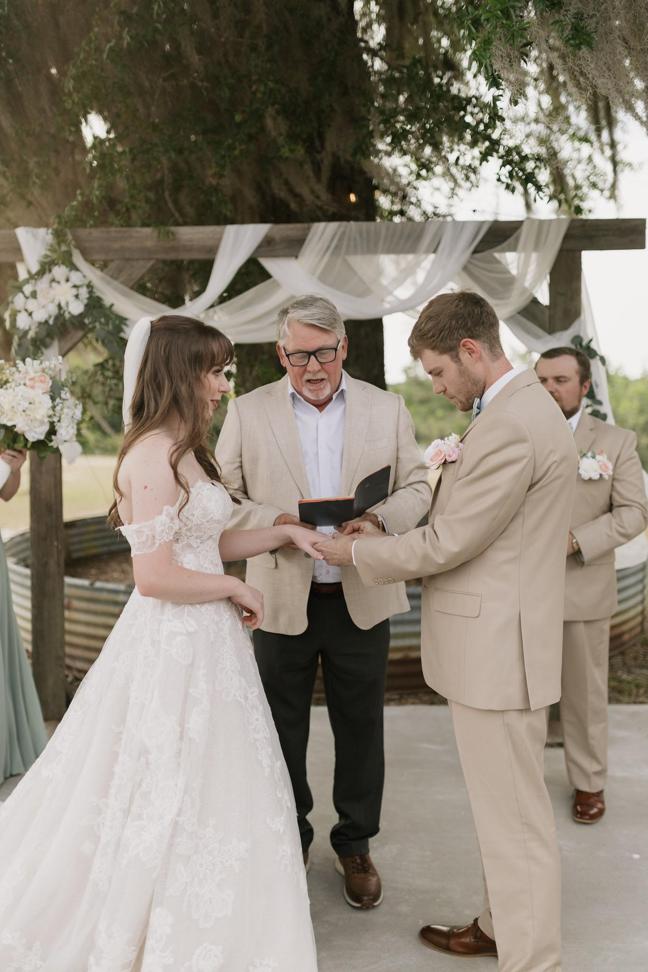
Every vendor who played a part in their wedding helped bring Jessica’s vision to life so beautifully. By blending talented local vendors, a few of their favorite businesses, and thoughtful personal touches they created themselves, every detail reflected the timeless, vintage, and ethereal aesthetic Jessica had dreamed of. Nothing felt overdone or out of place. It simply felt magical & perfect.
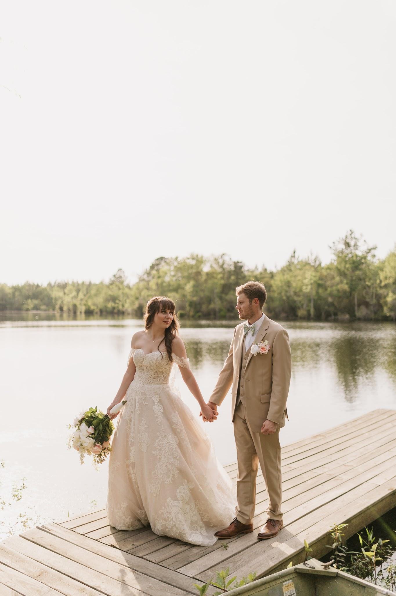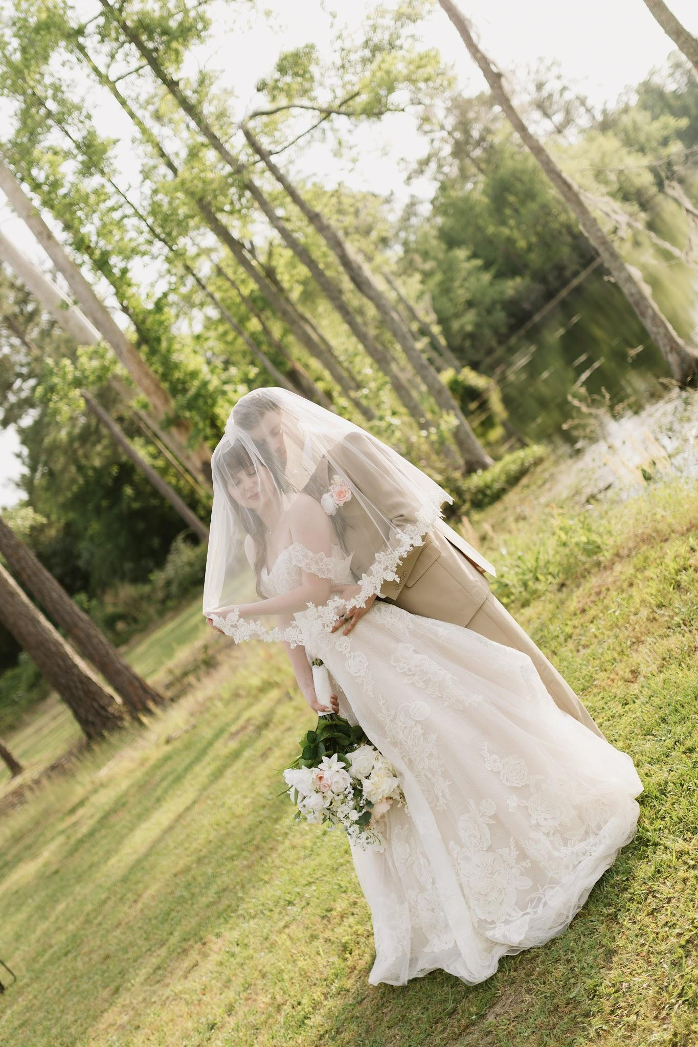
Being trusted to document this day was such an honor. Jessica & Gage, along with every friend, family member, and vendor who surrounded them, created an atmosphere that was full of love, laughter, and genuine connection. Days like this remind me why I love what I do, and I'm endlessly grateful I was the one who got to preserve these memories for them.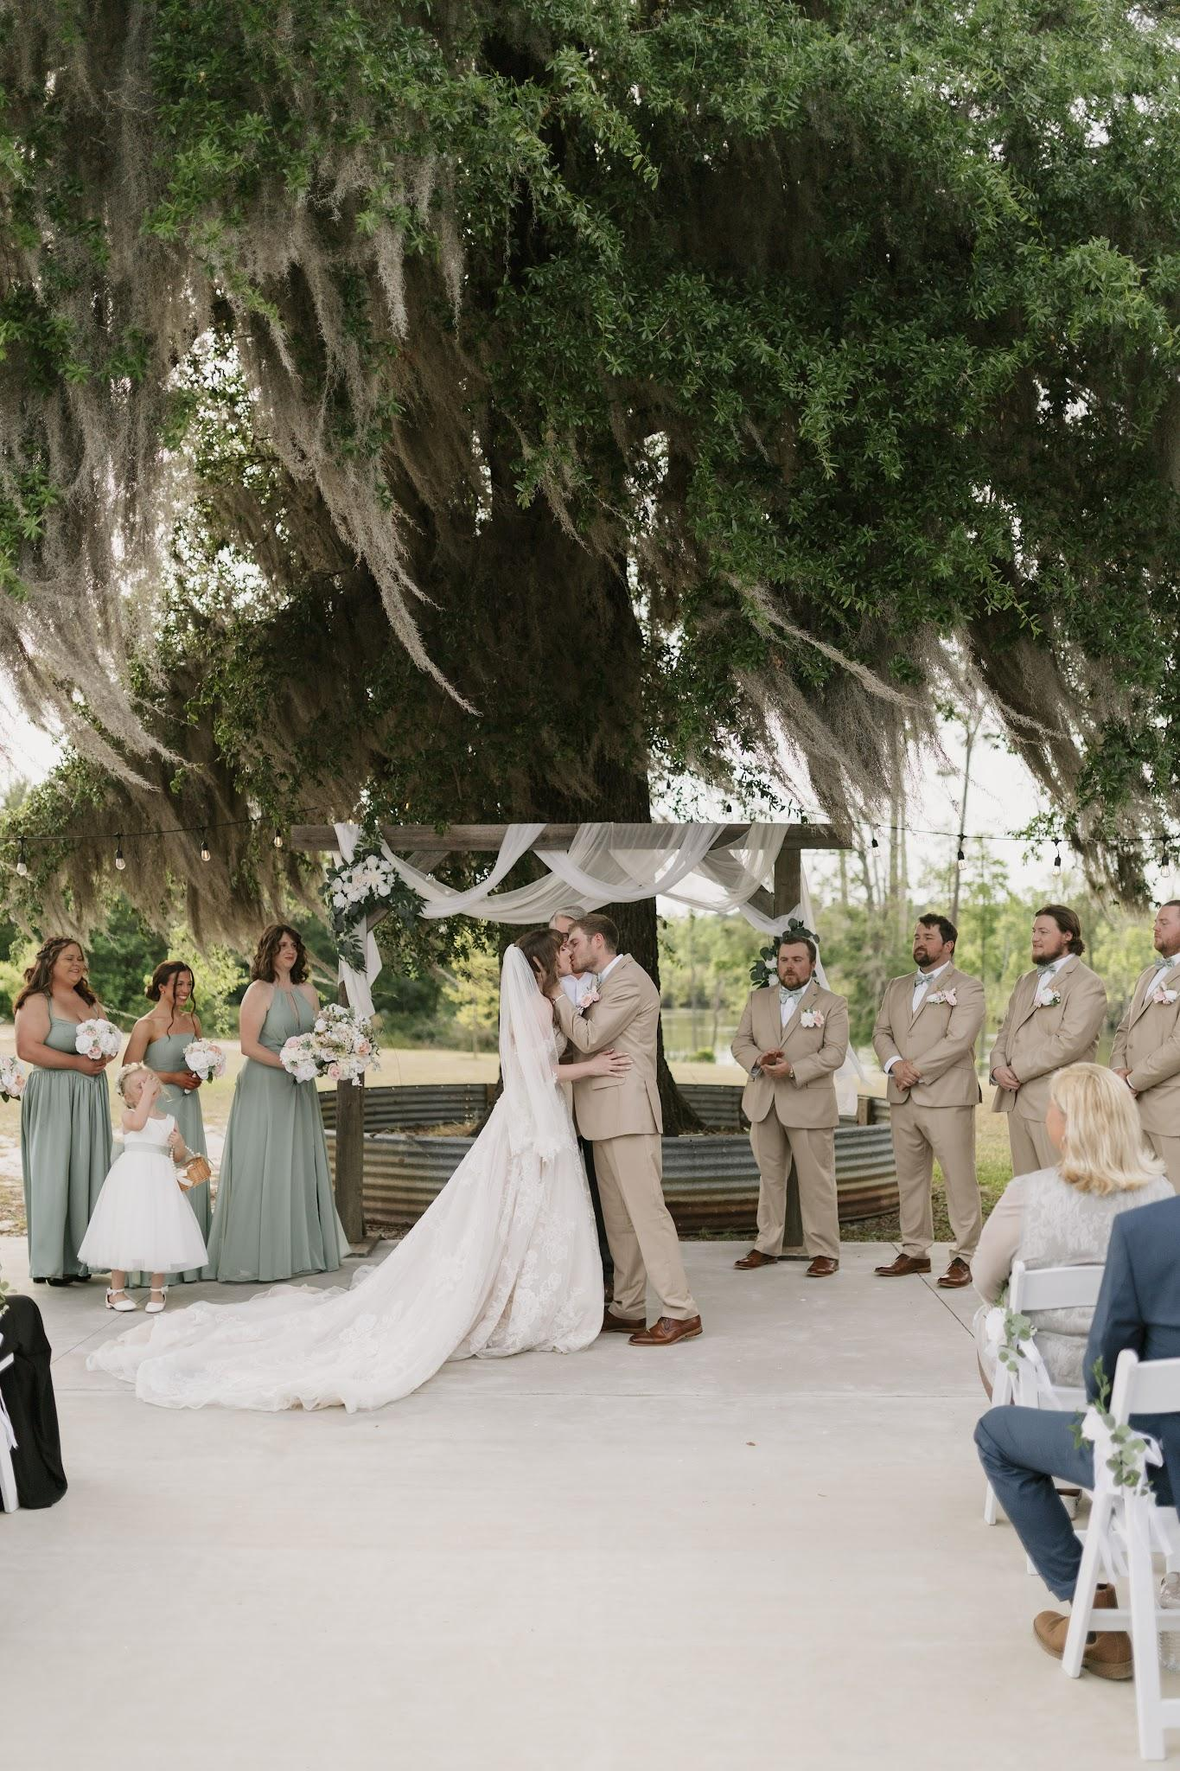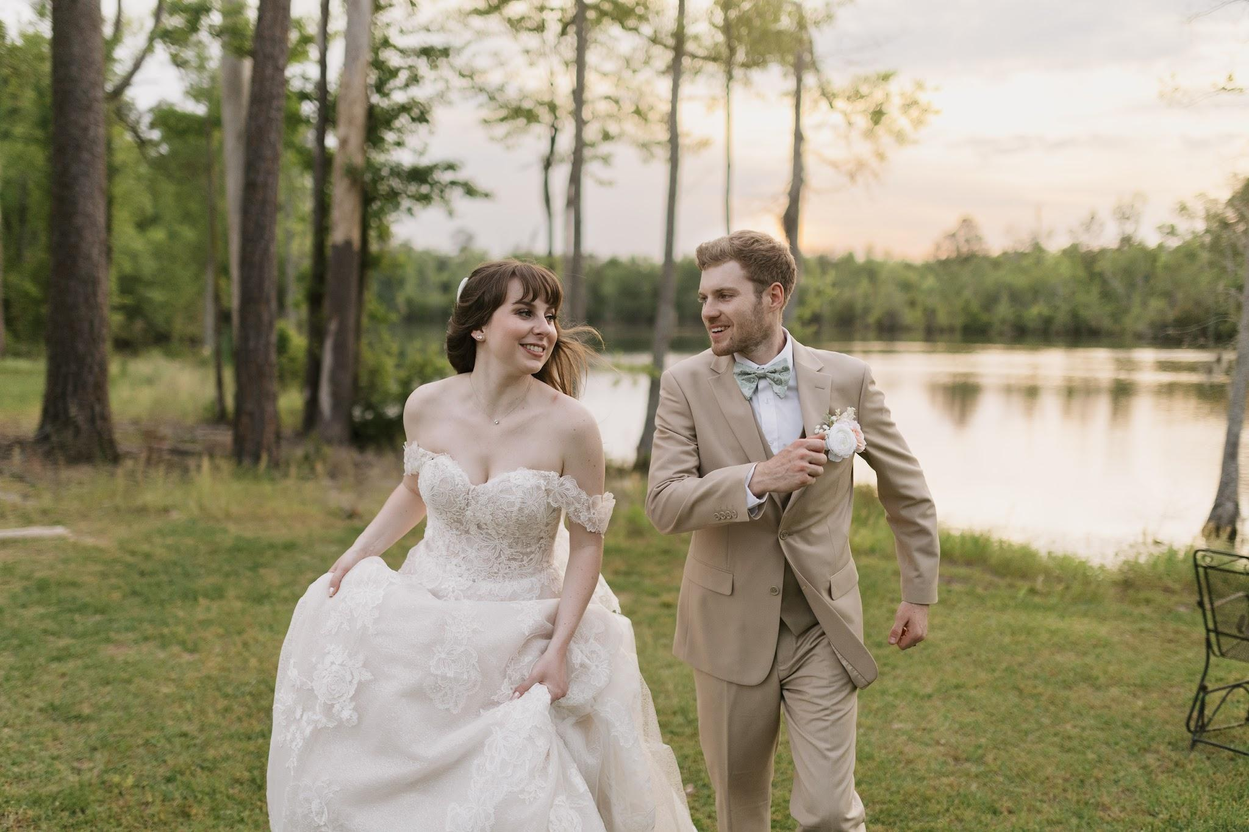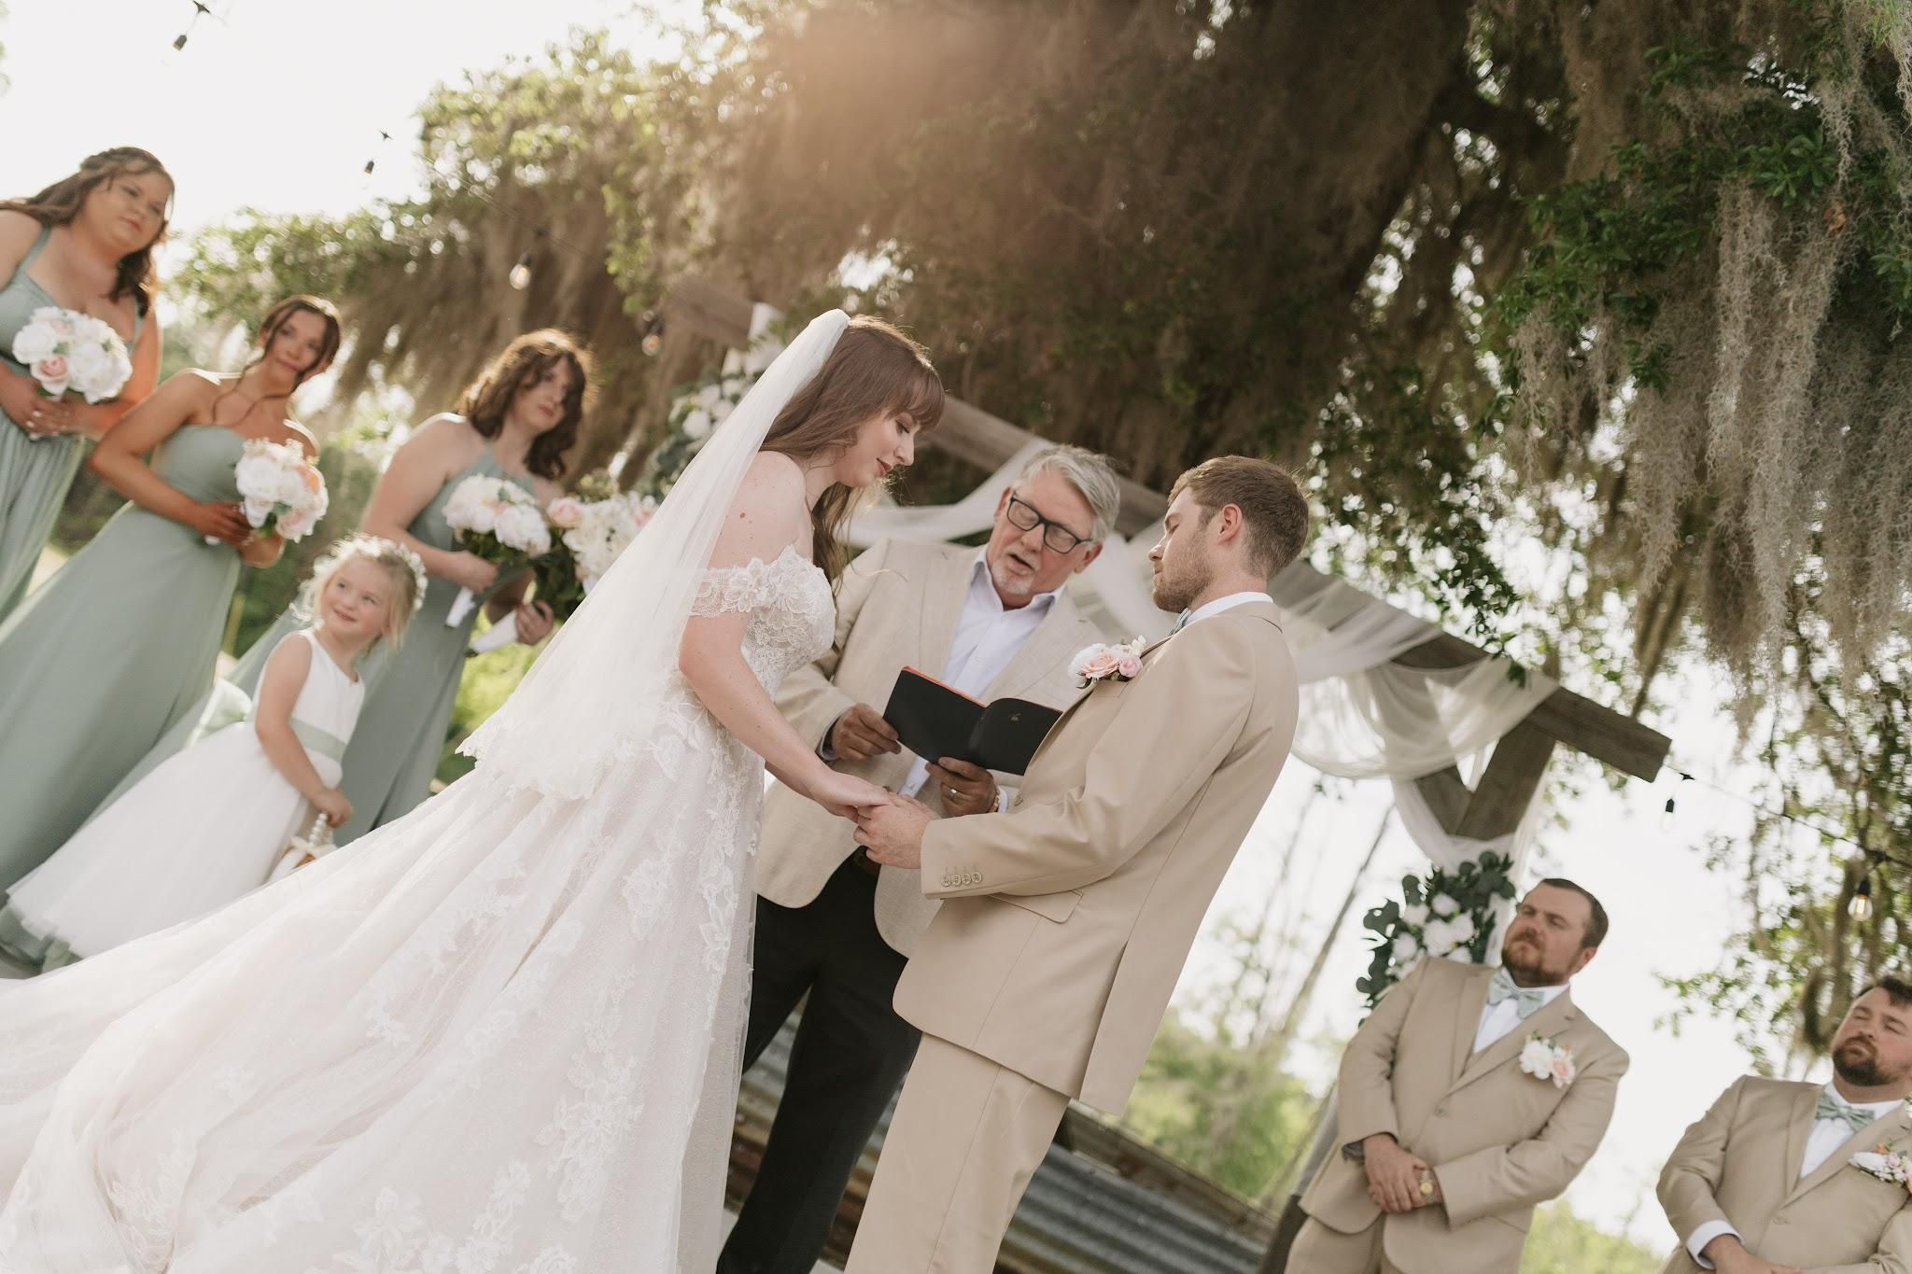
Vendors:
Venue: Sawtooth Acres
Coordinator: Louise Tilton
Rings: Galloway and Moseley’s
Wedding dress: Diamond Bride Couture
Bridesmaid dresses: Azazie
Cake: Lovett at First Bite Bakery
Catering: Stefanos
Shoes: Copper Key
Florals: Jessica Norton (Bride)
Hair: Kalyn Felix

